Dear Colleagues,

I am happy to share with you that we are currently trending at 98% goal capturing in Success Factors across the organization.
As of next week, we will start our goal quality audit ensuring that we are not only satisfied with the completion rate, but that we ensure employees are capturing SMART goals. We will Audit 5 % of the SAP native population from each division and will be working closely with your TM Leads to report findings.

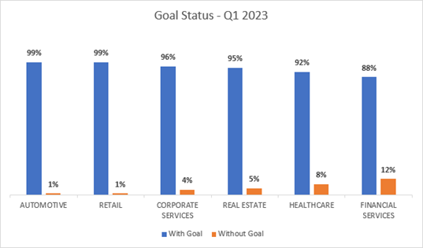

From a process perspective, our next step is Career Growth and IDP conversations. Accordingly, I would like to share the activation plan for Career Growth & IDP for the months of April through to June. This will allow more touch points to ensure we can take a more targeted approach towards covering our entire population. The recommended initiatives have been co-designed in collaboration with your TM leads, and over the next week, we will be liasing with your team to set out the Divisional activation plan.

Please feel free to reach out, should you require any additional support.

Regards.

Gabriella Planojevic
Group Head of Talent Management
Al Futtaim Group | Corporate – HR Function
* gabriella.planojevic@alfuttaim.com
È +971 507094638

